 | Transforming Tasks: Workshop 4 Handouts
 | Handout | Slide | Notes
1 | ‘From procedure to problem solving’  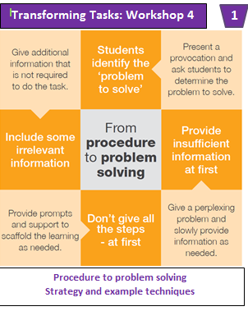Strategy and techniques | 3 | Provide each participant with an A5 copy of the ‘From procedure to problem solving’ strategy. This is located on the left hand side of the A4 sheet with Handout 3. It is recommended that these two handouts are separated before distribution.
2 | 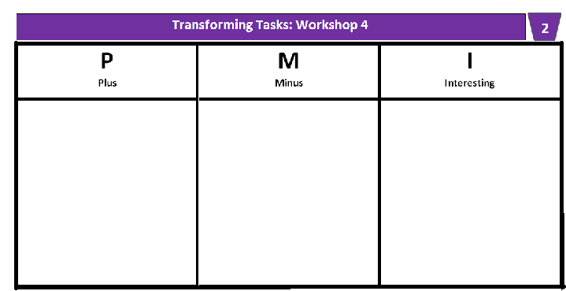  PMI chart | 7 | Each group of 2-3 participants will need an A4 copy of this handout.
3 | 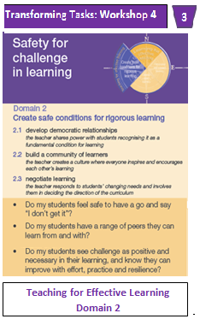Domain 2:  Safety for challenge in learning | 8 | Provide each participant with an A5 copy of the ‘Safety for challenge in learning’ handout. This handout is located on the A4 sheet with Handout 1. Separate the handouts before distribution.
4 | 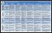Critical and creative thinking continuum | 14 | Participants each need an A3 copy of this handout.
5 | 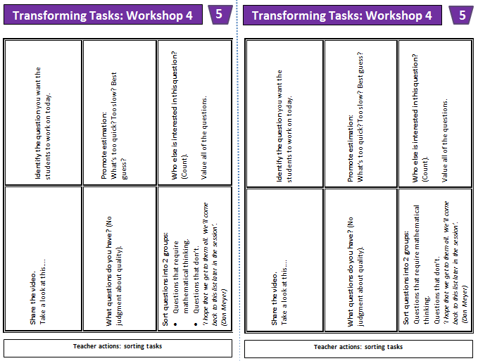Teacher actions: sorting cards | 18 | Each group of 2-3 participants will need a set of 6 teacher action sorting cards. There are two sets printed, ready for cutting, on each A4 sheet.
6  6 | ‘The burglar and the real estate agent’ text  (primary and/or secondary) | 41 | Participants each need an A4 copy of this handout.
7 | A3 sorting activity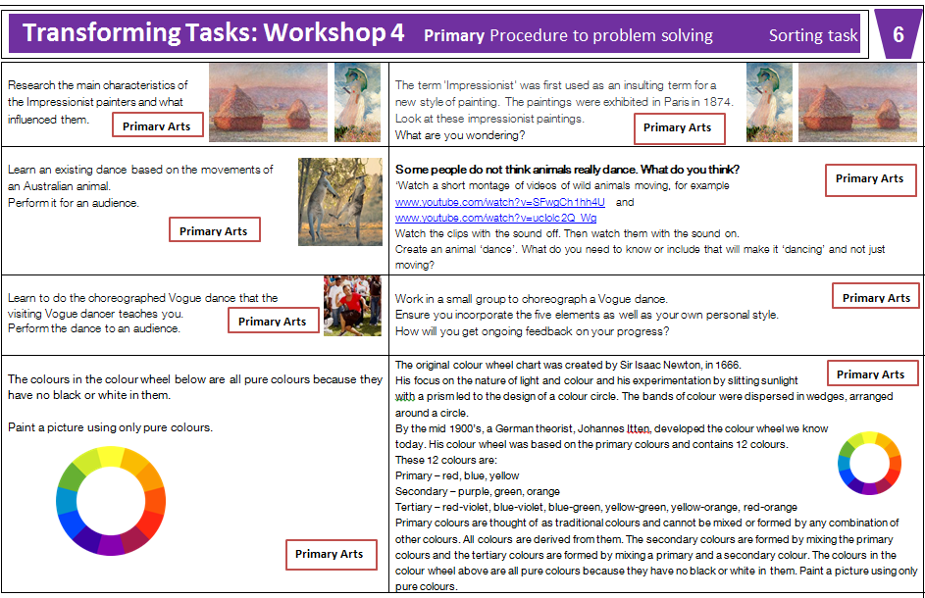 | 43 | Each group of 2-3 participants should have a cut up set of the 4 ‘before’ and the 4 ‘after’ examples from just one Learning Area, for either Primary or Secondary, as appropriate.
8 | 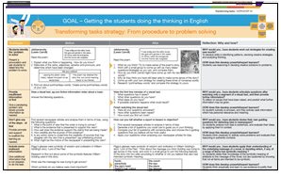‘From procedure to problem solving’ A3 before and after | 44 | Print sufficient A3 ‘Before and after’ handouts for each learning area, so that each participant can access the example they were considering in the previous activity.
9 | ‘From procedure to problem solving’ A3 ‘Have a go’  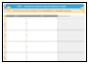 | 45 | Participants each need an A3 copy of this handout.

Transforming Tasks: Workshop 1
Icons

 | Meaning | Slides
1  A | Indicates that a handout for participants accompanies the slide. | 3, 7, 8, 14, 18, 41, 43, 44, 45
 | Indicates that participants engage in an activity. | 6, 7, 14, 18, 37, 40, 41, 43, 45
 | Indicates that participants engage in a discussion. | 4, 7, 8, 9, 13, 14, 17, 20, 26, 27, 29, 33, 38, 41, 42, 44, 46, 48
 | Indicates that participants watch a video. | 4, 17, 22, 35
 | Indicates that participants read something.
 | Indicates that a key message is introduced in the slide. | 8-9, 15, 33, 46

